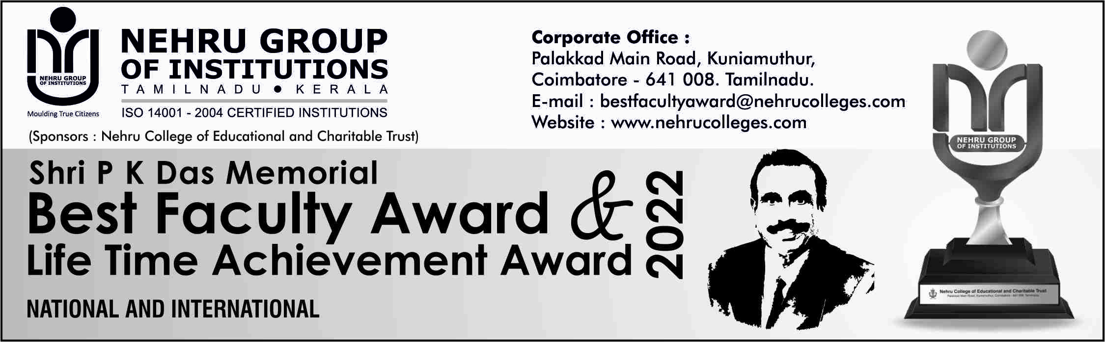
Name and Department of the Staff (NGI) referred: ……………………………………… APPLICATION FORM – JUNIOR
(Applicable for the Members of Faculty from Self-Financing Colleges only with 5 to 10 years of experience and still in regular service)

- Name (in Block Letters) :

Recent Photo

- Date of Birth :
- Designation :
- College / Institution / University :
- Department :
- Discipline :
- Area of Specialization :
- a. Residential Address :

b. Address for Communication :

c. Mobile No. :
d. Email ID :
- Qualification
Degree | Major | Specialization | Name of the College (with place) | Year of Passing | University | % of Marks / Rank if any
Ph. D.
M. Phil.
Master’s
Bachelor’s
- Additional Qualification
S. No | Course | Major | Specialization | University | Duration
1. | PDF
2. | P. G. / P. G. Diploma
3. | Any Other
- a) Professional Experience
S. No. | Designation | Years |  | Department | Name of the College/Organization
S. No. | Designation | From | To
- Teaching Experience as on 01.06.2022
Classes | No. of Years
P. G.
U. G.
U. G. & P. G.
12. Research Guidance (in numbers)
M. Phil. Ongoing Completed
Ph. D. Ongoing Completed
13. Research Projects
S. No | Title of the Project | Major / Minor | Funding Agency | Amount Sanctioned | Duration | Ongoing/  Completed
14. Visits Abroad
S. No | Country | Date of Visit | Purpose
15. Research Papers Published (in numbers)
Refereed Journals ( SCI & UGC Approved)
with Impact Factor > 1
International | National
Note: Science Citation Indexed / UGC Approved Journals only (Negative Marks for
Other Journals listed here)
16. Books Published
Publishers | No. of Books Published | ISBN / ISSN Number | Copy Right | Sole Author | Co – Author | In Chapters
International Level
National Level
Others/ Local
17. In House Magazines/News/Journals
S. No | Position | Name of Magazines / News / Journals | Period
S. No | Position | Name of Magazines / News / Journals | From | To
1 | Editor
2 | Member

18. Paper Presentation in Seminar/Conferences/Symposium/Workshop (in numbers)
State | National Level | International*
* Outside India only

19. Seminars / Events Organized (in numbers)
State | National Level | International*
* Outside India only
20. Role in
a. Co-curricular activities

b. Extracurricular activities

21. Awards/ Recognitions

22. Any other

Please Mention:
Are you a recipient of Best Faculty Award from NGI? If Yes, furnish the details of Discipline, Category and the year.
Yes No
N.B:
- No documents are required to be attached with the application
- Short listed candidates should attend the interview on 20.11.2022 at Nehru Arts and Science College, Nehru Gardens, Thirumalayampalayam, Coimbatore – 641 105 with the following:
    - A copy of the attested supporting documents
    - All original Documents
    - Two photographs
    - Power point presentation (for 15 minutes)
- The score of the presentation and interview will be added to the total merit of the candidate as per the application,
- Marks will be awarded on the basis of verification of original documents.
- The candidates top in the presentation and interview shall be awarded on 15.12.2022 at a prestigious and solemn function at P K Das Auditorium.
- Invitation will be sent to all the winners.
- The completed applications should be submitted on or before 15th October, 2022.

- Those who have already received the NGI Best Faculty Award are not eligible to apply for five years.

Declaration
I hereby declare that the information furnished is true to the best of my knowledge.

Name :
Signature :
Date :

Certificate
Certified that I have verified the facts furnished above and found to be true.
Forwarded for consideration

PRINCIPAL / REGISTRAR
(Name and Signature)
Note: Certificates (Original and Copies to be brought for the Interview)

